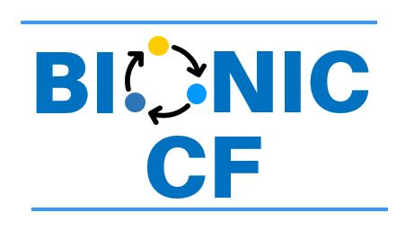

Do YOU have Cystic Fibrosis-Related Diabetes?

Do you want to try a Bionic Pancreas?
Researchers at the Children’s Mercy Hospital are looking for volunteers to test the Insulin-only iLet Bionic Pancreas from Beta Bionics.

The iLet Bionic Pancreas uses a continuous glucose monitor (CGM) and a computer program to automatically deliver insulin through a pump every 5 minutes. The iLet Bionic Pancreas is cleared by the FDA for people with type 1 diabetes ages 6 and older but is considered experimental in people with CFRD.
You may be eligible if:
- You are 14 years or older
- You have a documented diagnosis of Cystic fibrosis-related diabetes
- You have been on insulin therapy for at least the past 3 months
- You have been on the same insulin regimen for at least the past 1 month

What will happen?
- A Screening visit to determine if you are eligible (about 2-3 hours)
- A 14-day period of CGM data collection if you don’t regularly use a Dexcom G6 or G7 CGM
- One of two arms
  - One 13-week main study period with the iLet Bionic Pancreas (BP arm), followed by another 13-week extension period with the iLet Bionic Pancreas OR
  - One 13-week main study period of your usual diabetes care with a Dexcom CGM (Usual Care arm), followed by one 13-week extension period with the iLet Bionic Pancreas
- The first 13-week study period has at least 5 virtual visits and 2 in-person visits
- The second 13-week study period has at least:
  - 1 virtual visit and 1 in-person visit for the BP arm OR
  - 5 virtual visits and 2 in-person visit for the Usual Care arm
- In person visits can be completed virtually over telehealth if necessary

Will I Be Paid?
- You will be given:
  - $80 for the screening visit
  - $355 for completing main study & extension phase of the BP arm
OR
$415 for completing main study & extension phase of the Usual Care arm
- An additional $210 will be given for your participation in the optional substudies

IF YOU ARE INTERESTED, PLEASE CONTACT Kelsye Howell at klhowell@cmh.edu

