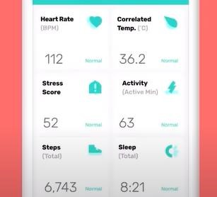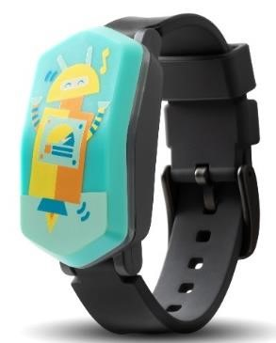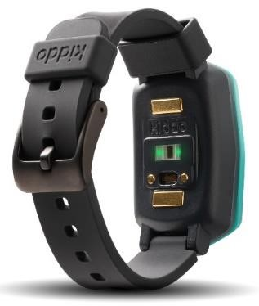

**Kiddo**

**Study**

•

**Do**

**es**

**you**

**r child**

**have Type 1 Diabetes**

**(**

**T1D**

**)**

**?**

•

**Is**

**you**

**r**

**child**

**between the ages of 3 and 9**

**years old**

**?**

•

**Would you**

**consider allowing your child to**

**wear the kiddo**

**wristband for 90 days to test how it might help**

**patients just like**

**them**

**with T1D?**

About the Kiddo Device:

The Kiddo device tracks a child’s vitals and

health behavior and sends this information to

the Kiddo

app

. P

arents receive daily

notifications about health, activity, and sleep

levels.

Kiddo has many other features as well.

You

can set goals and earn points

. There is

also a library of resources

on food, activities,

and more.

About the Study:

•

Your child will wear 2 devices for 7

days and 1 device for 90 days.

•

You and your child

will complete a

few

surveys

.

•

Families will be compensated for

participation.

**Please reach out**

**if you are interested in participating**

**.**

**Thank you for your consideration!**

**Priscilla Connell**

Research Coordinator

(816) 601-4543

**pcconnell@cmh.edu**